

DRPOWER PRODUCT PRICE LIST 2026
Distributor price in KES
HYBRID AND SOLAR INVERTERS
Item | Model | Photo | TECHNICAL KEY FEATURES | Distributor Price (KES) | Warranty
1 | DPGA1200 | 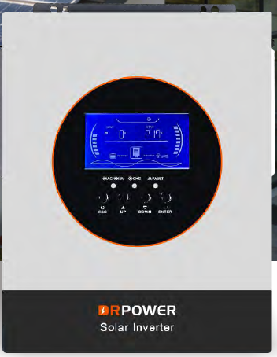 | • 1.2 kW  • 12 V  • Pure sine wave output
2 | DPGA3624 |  | • 3.6 kW  • 24 V  • Pure sine wave output
3 | DPGA6248 |  | • 6.5 kW  • 48 V  • Pure sine wave output
4 | DPGA12000 |  | • 12 kW  • 48 V  • Pure sine wave output
5 | DPGA6248B |  | • 6.5 kW  • 48 V  • parallel  • Pure sine wave output
6 | DP1512 | 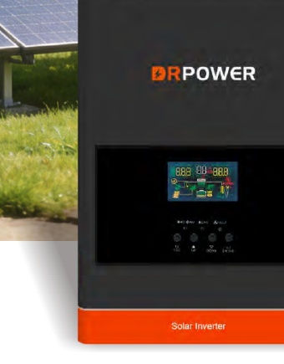 | • 1.2 kW  • 12 V  • Pure sine wave output
Source: DRPOWER 2026 catalogue. Photos represent the catalogue product series.

DRPOWER PRODUCT PRICE LIST 2026
Distributor price in KES
HYBRID AND SOLAR INVERTERS
Item | Model | Photo | TECHNICAL KEY FEATURES | Distributor Price (KES) | Warranty
7 | DP2024 |  | • 1.6 kW  • 24 V  • Pure sine wave output
8 | DPED3024EMH | 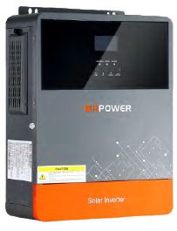 | • 3 kW  • 24 V  • Pure sine wave output
9 | DPED6248EMH |  | • 6.2 kW  • 48 V  • Pure sine wave output
10 | DPED11048EMH | 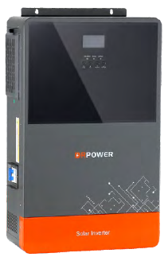 | • 11 kW  • 48 V  • Pure sine wave output
11 | DPT3624SMH | 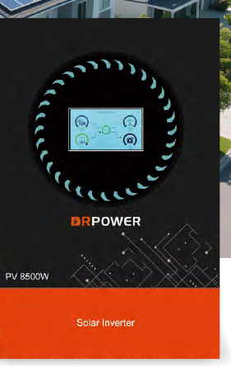 | • 3.6 kW  • 24 V  • touchscreen  • Pure sine wave output
12 | DPT6248SMH |  | • 6.2 kW  • 48 V  • touchscreen  • Pure sine wave output
Source: DRPOWER 2026 catalogue. Photos represent the catalogue product series.

DRPOWER PRODUCT PRICE LIST 2026
Distributor price in KES
HYBRID AND SOLAR INVERTERS
Item | Model | Photo | TECHNICAL KEY FEATURES | Distributor Price (KES) | Warranty
13 | DPT11048SMH |  | • 11 kW  • 48 V  • touchscreen  • Pure sine wave output
14 | DPED11048EMHB |  | • 11 kW  • 48 V  • parallel  • Pure sine wave output  • Specification to confirm
15 | DPGD4500 | 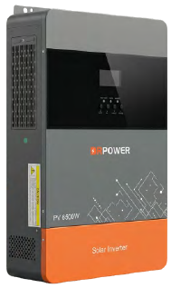 | • 4.5 kW  • 24 V  • Pure sine wave output
16 | DPGD6500 |  | • 6.5 kW  • 48 V  • Pure sine wave output
17 | DPGD11100 |  | • 11 kW  • 48 V  • Pure sine wave output  • Specification to confirm
18 | DPECO-3K12V-HV | 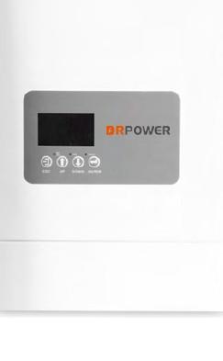 | • 3 kW  • 12 V  • 230 V AC  • Pure sine wave output
Source: DRPOWER 2026 catalogue. Photos represent the catalogue product series.

DRPOWER PRODUCT PRICE LIST 2026
Distributor price in KES
HYBRID AND SOLAR INVERTERS
Item | Model | Photo | TECHNICAL KEY FEATURES | Distributor Price (KES) | Warranty
19 | DPECO-4.5K24V-HV |  | • 4.5 kW  • 24 V  • 230 V AC  • Pure sine wave output
20 | DPECO-5.5K48V-HV |  | • 5.5 kW  • 48 V  • 230 V AC  • Pure sine wave output  • Specification to confirm
21 | DPECO-6.5K48V-HV |  | • 6.5 kW  • 48 V  • 230 V AC  • Pure sine wave output
22 | DPECO-4K24V-LV |  | • 4 kW  • 24 V  • 120 V AC  • Pure sine wave output
23 | DPUPS50112/24 | 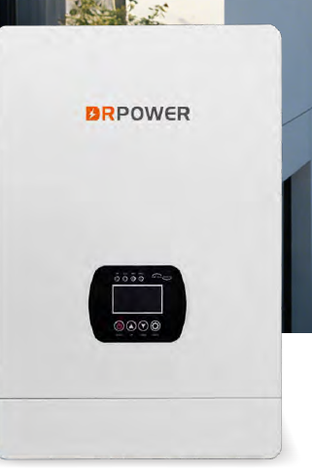 | • 0.5 kW  • 12 V  • Pure sine wave output  • Specification to confirm
24 | DPUPS10224/48 |  | • 1 kW  • 24/48 V  • Pure sine wave output
Source: DRPOWER 2026 catalogue. Photos represent the catalogue product series.

DRPOWER PRODUCT PRICE LIST 2026
Distributor price in KES
HYBRID AND SOLAR INVERTERS
Item | Model | Photo | TECHNICAL KEY FEATURES | Distributor Price (KES) | Warranty
25 | DPUPS30224/48 |  | • 3 kW  • 24/48 V  • Pure sine wave output
26 | DPUPS50248 |  | • 5 kW  • 48 V  • Pure sine wave output
27 | DPUPS80248 |  | • 8 kW  • 48 V  • Pure sine wave output
28 | DPSH-6.2K-48V-EU | 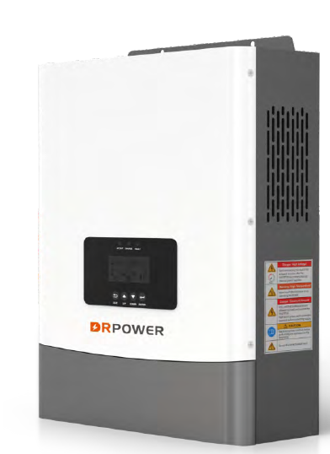 | • 6.2 kW  • 48 V  • IP54  • Pure sine wave output
29 | DPSH-12K-48V-EU |  | • 12 kW  • 48 V  • IP54  • Pure sine wave output
30 | DPW48P1-3kW | 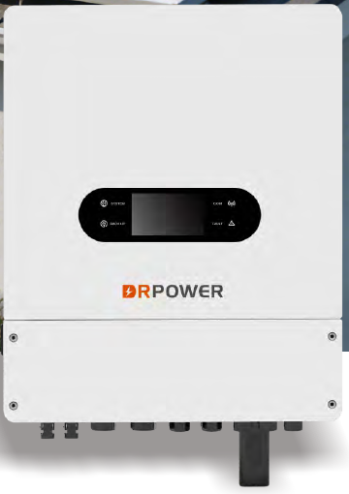 | • 3 kW  • 48 V  • single-phase  • IP66  • Pure sine wave output
Source: DRPOWER 2026 catalogue. Photos represent the catalogue product series.

DRPOWER PRODUCT PRICE LIST 2026
Distributor price in KES
HYBRID AND SOLAR INVERTERS
Item | Model | Photo | TECHNICAL KEY FEATURES | Distributor Price (KES) | Warranty
31 | DPW48P1-4kW |  | • 4 kW  • 48 V  • single-phase  • IP66  • Pure sine wave output
32 | DPW48P1-5kW |  | • 5 kW  • 48 V  • single-phase  • IP66  • Pure sine wave output
33 | DPW48P1-6kW |  | • 6 kW  • 48 V  • single-phase  • IP66  • Pure sine wave output
34 | DPW48P1-8kW |  | • 8 kW  • 48 V  • single-phase  • IP66  • Pure sine wave output
35 | DPW48P3-8kW | 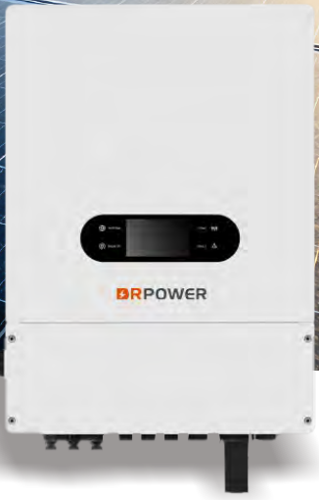 | • 8 kW  • 48 V  • three-phase  • IP66  • Pure sine wave output
36 | DPW48P3-10kW |  | • 10 kW  • 48 V  • three-phase  • IP66  • Pure sine wave output
Source: DRPOWER 2026 catalogue. Photos represent the catalogue product series.

DRPOWER PRODUCT PRICE LIST 2026
Distributor price in KES
HYBRID AND SOLAR INVERTERS
Item | Model | Photo | TECHNICAL KEY FEATURES | Distributor Price (KES) | Warranty
37 | DPW48P3-12kW |  | • 12 kW  • 48 V  • three-phase  • IP66  • Pure sine wave output  • Specification to confirm
38 | DPW48P3-15kW |  | • 15 kW  • 48 V  • three-phase  • IP66  • Pure sine wave output
Source: DRPOWER 2026 catalogue. Photos represent the catalogue product series.

DRPOWER PRODUCT PRICE LIST 2026
Distributor price in KES
ALL IN ONE SOLAR SYSTEMS
Item | Model | Photo | TECHNICAL KEY FEATURES | Distributor Price (KES) | Warranty
39 | DPMES300-1000WH | 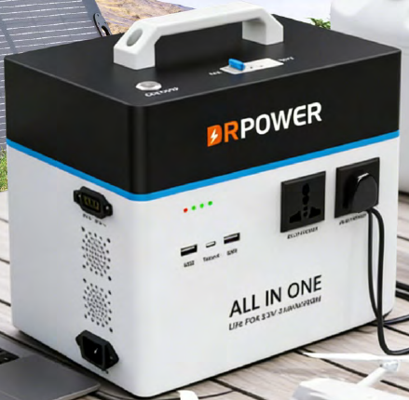 | • 300 W inverter + 1 kWh battery
40 | DPMESL3000-5248WH | 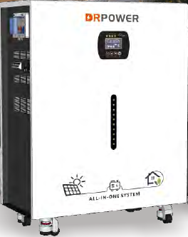 | • 3 kW + 5.12 kWh  • low-frequency  • 51.2 V  • Specification to confirm
41 | DPMESL3000-10240WH |  | • 3 kW + 10 kWh  • low-frequency  • 51.2 V  • Specification to confirm
42 | DPMESL5000-10240WH |  | • 5 kW + 10 kWh  • low-frequency  • 51.2 V  • Specification to confirm
43 | DPMESL5000-15000WH |  | • 5 kW + 15 kWh  • low-frequency  • 51.2 V
44 | DPMESL8000-15000WH |  | • 8 kW + 15 kWh  • low-frequency  • 51.2 V
Source: DRPOWER 2026 catalogue. Photos represent the catalogue product series.

DRPOWER PRODUCT PRICE LIST 2026
Distributor price in KES
ALL IN ONE SOLAR SYSTEMS
Item | Model | Photo | TECHNICAL KEY FEATURES | Distributor Price (KES) | Warranty
45 | DPMESH3600-5248HG | 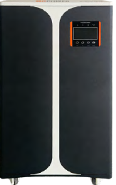 | • 3.6 kW + 5.248 kWh  • high-frequency  • Specification to confirm |  | 2 Years
46 | DPMESH3600-8000HG |  | • 3.6 kW + 8 kWh  • high-frequency  • Specification to confirm |  | 2 Years
47 | DPMESH6500-16000HG |  | • 6.5 kW + 16 kWh  • high-frequency  • Specification to confirm |  | 2 Years
48 | DPMESH11000-16000HG |  | • 11 kW + 16 kWh  • high-frequency  • Specification to confirm |  | 2 Years
Source: DRPOWER 2026 catalogue. Photos represent the catalogue product series.

DRPOWER PRODUCT PRICE LIST 2026
Distributor price in KES
LITHIUM BATTERIES AND ENERGY STORAGE
Item | Model | Photo | TECHNICAL KEY FEATURES | Distributor Price (KES) | Warranty
49 | DPSLF512100 | 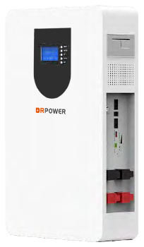 | • 5.12 kWh  • 51.2 V  • 100 Ah  • LiFePO4  • RS485 / RS232 / CAN
50 | DPSLF512200 | 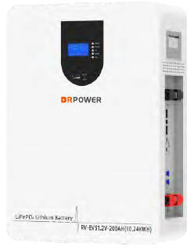 | • 10.24 kWh  • 51.2 V  • 200 Ah  • LiFePO4  • RS485 / RS232 / CAN
51 | DPSLF512300 | 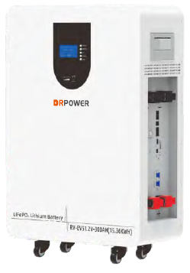 | • 15.36 kWh  • 51.2 V  • 300 Ah  • LiFePO4  • RS485 / RS232 / CAN
52 | DPSLFH30KWH | 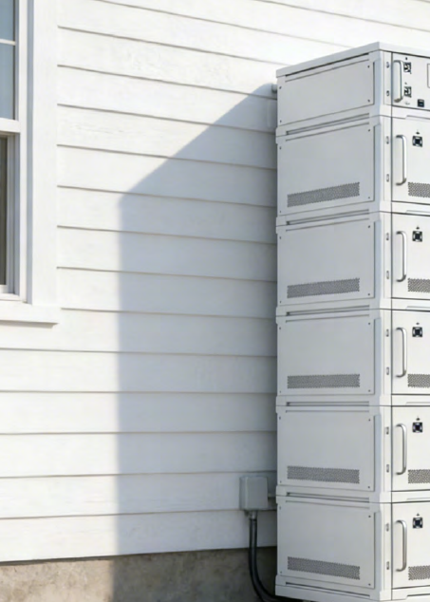 | • 29.952 kWh  • 288 V  • 104 Ah
53 | DPSLFH67KWH |  | • 67.2 kWh  • 240 V  • 280 Ah
54 | DPSLFH128KWH |  | • 128.614 kWh  • 409.6 V  • 314 Ah
55 | DPESS130K261KWH | 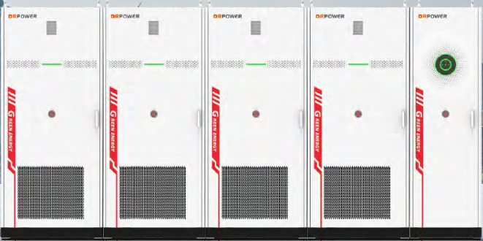 | • 130 kW + 261 kWh  • three-phase
Source: DRPOWER 2026 catalogue. Photos represent the catalogue product series.

